

# Quarterly Update

October 2023

## Gas Industry Co is the home of New Zealand’s gas governance, advice, and data.

Gas Industry Co is the industry co-regulator, working with industry and government for safe, efficient, reliable, fair, and sustainable gas delivery.

The [Government Policy Statement on Gas Governance](https://www.gasindustry.co.nz/assets/DMSDocumentsOld/rules-and-regulations/4791GPS-2008.pdf) requires us to report quarterly to the Minister of Energy on our progress towards meeting the Government’s objectives and outcomes for the gas industry and any Ministerial requests that may arise from time to time. This report to the caretaker Minister fulfils the requirement. A briefing will be provided to the incoming Minister upon appointment and later published on our website.

#### Gas Today

## Gas supply and demand steady

While gas production was relatively steady over the past three months, there were significant changes in demand patterns over the winter months.



Consumption data in the graph above shows that Methanex’s gas use roughly halved between July and September. This reflects an arrangement between Genesis and Methanex, under which Genesis purchases 3.4-4.4 PJ of gas over winter. The arrangement, agreed in 2021, has continued in subsequent years. The majority of this gas went to electricity production at both Genesis’s Huntly power station and Contact’s Taranaki Combined Cycle power station.

## Gas production



*Excludes gas sold through private pipelines.

This graph breaks down the production of gas delivered through the open access pipeline network by field. Overall production was steady through the quarter, with a few brief outages at Pohokura.

Gas Transition Plan work update

MBIE published a Gas Transition Plan Issues Paper on 9 August, along with four other papers regarding hydrogen, offshore energy, electricity markets and banning thermal baseload. The Issues Paper was compiled in conjunction with Gas Industry Co. Important points in the Issues Paper include:

* Gas continues to be needed through the transition;
* Recognition of the need to maintain energy security while demand for gas declines. This will require "ongoing investment in fossil gas production, distribution, and transmission assets";
* Petrochemicals are needed to underpin investment in gas production;
* A shift away from gas for baseload electricity produces the largest emissions reductions in the 2020s, but there is uncertainty over investment in gas deliverability; and
* Biogas is a low impact solution to decarbonize residential and small commercial consumers.
* CCUS can have a significant role in the decarbonization of industry.

Supporting reports, containing detailed economic and technical data that are likely to be valuable to industry participants planning for the transition, have been published on MBIE and [GIC websites](https://www.gasindustry.co.nz/our-work/work-programmes/gas-transition/#developing), and include topics such as:

* renewable gases including, separately, hydrogen and biogas,
* a technical study of the feasibility of carbon capture, and a study of the regulatory framework for emissions capture,
* whether regulatory changes are needed for the transmission system, and
* options for security of supply if insufficient natural gas is available.

Gas Industry Co has continued to work with MBIE’s new gas transition plan team to provide insights about issues in the sector and options available to various gas segments.

Targeted engagement with industry around specific draft initiatives will continue in the second half of 2023.

# Gas Industry Insights

Comprehensive, timely gas sector information is available in our [data portal](https://www.gasindustry.co.nz/data/)

Data available for market participants includes daily gas production by major fields and consumption by the largest users, data about volumes of gas in the Ahuroa gas storage facility, and average quarterly gas prices and supply.

Market analysts looking for detail about prices can quickly locate emsTradepoint daily gas prices and delivered quantities.

Detail to support security of supply, and help markets understand energy availability, is provided through a portal recording planned gas production outages.

## Quarterly Data

## Residential switching annual churn rate of 15%

## Over the past 12 months an average of 3,805 switches per month were completed, which translates to an annual churn rate of about 15 percent.

|  |  |  |  |
| --- | --- | --- | --- |
|  | **July** | **August** | **September** |
| **2022** | 3819 | 4165 | 3571 |
| **2023** | 4129 | 4529 | 4155 |



## Around 78 per cent of consumer switches are completed within three business days and 97 percent are completed within seven business days.

## Commercial and industrial prices have increased over the past year



MBIE quarterly prices for commercial, industrial, and wholesale sectors have changed at different rates during the past 12-months. These prices are representative of all natural gas produced in New Zealand and exclude GST.

Around 95% of gas is traded via long-term bilateral contracts. In the chart above, prices rose steeply between September and December 2021 for the smaller volumes of gas being purchased by commercial consumers coming off contract and have remained elevated since.

Industrial prices rose sharply between September and December 2022, but settled back down by March 2023.

**Monthly Spot Prices: trending down**



* Spot price includes daily trades and forward prices. Shown prices exclude GST but include carbon costs.

This graph shows the average, maximum and minimum price per month on gas delivered via emsTradepoint. This covered approximately 4% of the total gas produced in 2022.

**Upcoming planned outages**

This graph shows all planned outages that have been disclosed through our new [outage disclosure page](https://outagedisclosure.gasindustry.co.nz/). For more information on planned gas production outages, see our [website](https://www.gasindustry.co.nz/data/planned-outages/).

#### Our Work in Progress

## The Gas Industry Co Annual Report was published in September

Our Annual Report process includes a reflection on the past financial year’s work programme, upcoming strategy, financial statements, corporate governance, and co-regulation.

The Annual Report was delivered to the Minister, then gazetted and published on our [website](https://www.gasindustry.co.nz/assets/DMSDocumentsOld/annual-reports/2023-Gas-Industry-Company-Annual-Report.pdf).

## Upcoming changes to gas governance arrangements

Gas Industry Co is working on a Statement of Proposal (SOP) for a coordinated set of changes to the Reconciliation Rules and Switching Rules that support market-led activities including:

* rollout of advanced gas meters,
* D+1 (daily allocations),
* the upcoming trial injection of biomethane in gas networks.

We intend to release the SOP in November 2023.

Gas Industry Co will also use the opportunity to propose changes collected on rule change registers over the last few years. We aim to provide a recommendation to the Minister in early 2024.

This will ensure our gas governance arrangements remain fit for purpose for the next period.

## Upcoming changes to the Gas Governance (Critical Contingency Management) Regulations 2008 (CCM Regulations)

Gas Industry Co is working on an SOP to improve the CCM Regulations. Most of the proposals concern minor changes, either to clarify obligations, remove ambiguity, update wording, or adapt processes to operational reality.

Apart from changes to make the curtailment order more efficient, there is one change which is materially different to the previously released SOP.

In October 2021, following the initial consultation and submission round, Firstgas requested further changes to the regulations governing how critical contingency pressure thresholds for the transmission system are set. It sought more operational flexibility. We asked First Gas to undertake additional consultation in relation to this proposed change as the change is intended to facilitate operation of the transmission system at a lower pressure. Transmission pressure has the potential to impact other system users.

One of First Gas’s proposed changes relates to the removal of the Taupo and Broadlands points of measurement. Operational changes to this section of transmission system relate to injection of biomethane into the First Gas transmission pipeline at Broadlands near Reporoa, which is expected to commence from March 2024. The proposed change is being considered as an urgent regulation change. An urgent regulation change requires an ex-post consultation, which will occur through the SOP.

We intend to release the SOP on changes to the CCM Regulations open for consultation in late2023. Gas Industry Co aims to provide a recommendation to the Minister in 2024.

This will ensure the CCM Regulations remain fit for purpose for the next period.

Unaccounted for gas

Unaccounted for gas (UFG) is the difference between the volume of gas injected into each distribution network and retailers’ submissions for the volume their customers have used. Unaccounted for gas typically arises from retailer estimation error, metering or energy conversion inaccuracies. The cost of unaccounted for gas is spread across all retailers depending on their customer mix.

The below graph shows that UFG (12-month rolling total) increased significantly after late 2019. In response, Gas Industry Co carried out a review of UFG at individual gas gates and set up monthly monitoring at each gate as new data for gas injections and retailer submissions arrive. This initial work has helped to curb further increases and, as a result, UFG peaked in June 2022.

Gas Industry Co also learned that not all industry participants have been strictly compliant with their monthly meter read requirements for small to medium sized commercial gas users (i.e. allocation group 4) which has been highlighted a risk for further UFG reductions. A self-breach notice was received relating to one industry participant and Gas Industry Co, in its role as Market Administrator, is in the process of determining materiality of this issue.

This work will serve to either highlight or rule out meter reading compliance for small commercial businesses as a contributing factor to UFG.

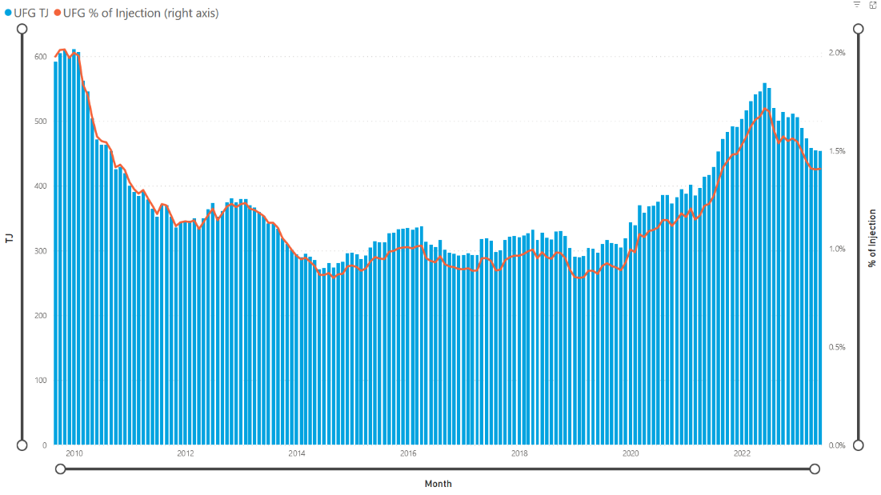

#### About Us

Gas Industry Co is the industry body that co-regulates gas to ensure New Zealanders enjoy safe, efficient, fair, reliable, and environmentally sustainable gas delivery.

We work closely with industry players and regulatory agencies to develop arrangements and regulations and we provide trusted advice to industry and government about issues in the gas industry.

To get in touch or to find out more about the work we do, please contact us on 04 472 1800 or at [info@gasindustry.co.nz](mailto:info@gasindustry.co.nz) or head to our website [www.gasindustry.co.nz](http://www.gasindustry.co.nz)